To use Git, you have to install it on your computer. Even if you have already installed Git, it's probably a good idea to upgrade it to the latest version. You can either install it as a package or via another installer or download it from its official site.

Now the question arises that how to download the Git installer package. Below is the stepwise installation process that helps you to download and install the Git.

How to download Git?

**Step1**oncepts in Java

To download the Git installer, visit the Git's official site and go to download page. The link for the download page is <https://git-scm.com/downloads>. The page looks like as



Click on the package given on the page as **download 2.23.0 for windows**. The download will start after selecting the package.

Now, the Git installer package has been downloaded.

Install Git

**Step2**

Click on the downloaded installer file and select **yes** to continue. After the selecting **yes** the installation begins, and the screen will look like as

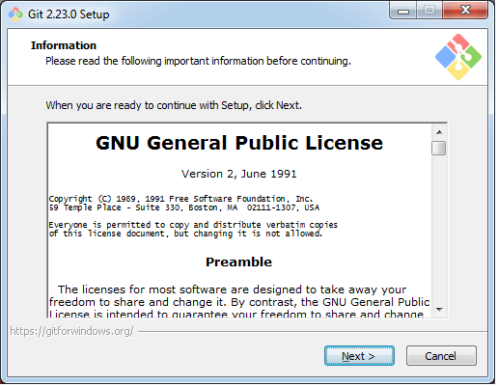

Click on **next** to continue.

**Step3**

Default components are automatically selected in this step. You can also choose your required part.

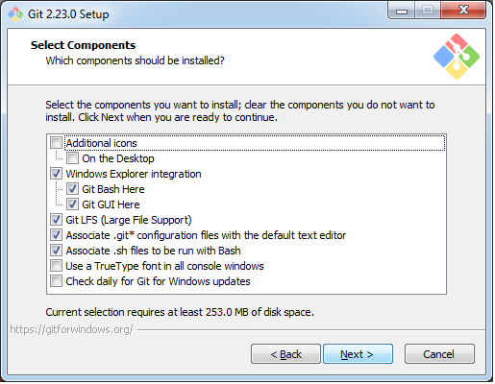

Click next to continue.

**Step4**

ADVERTISING

The default Git command-line options are selected automatically. You can choose your preferred choice. Click **next** to continue.

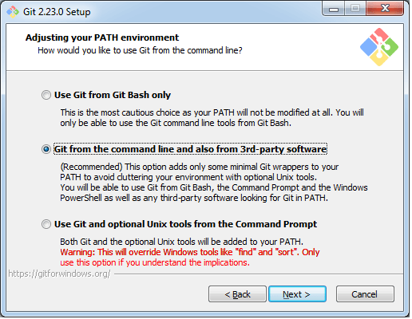

**Step5**

The default transport backend options are selected in this step. Click **next** to continue.

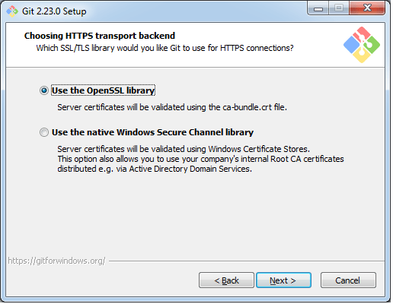

**Step6**

Select your required line ending option and click next to continue.

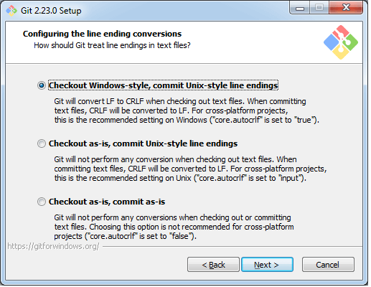

**Step7**

Select preferred terminal emulator clicks on the **next** to continue.

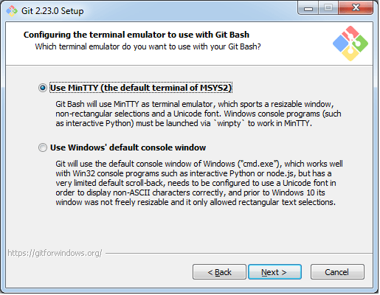

**Step8**

This is the last step that provides some extra features like system caching, credential management and symbolic link. Select the required features and click on the **next** option.

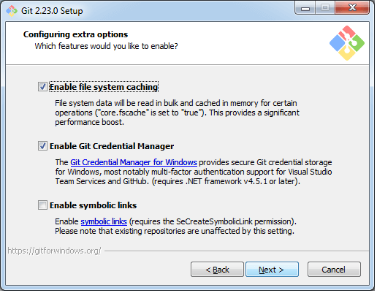

**Step9**

The files are being extracted in this step.

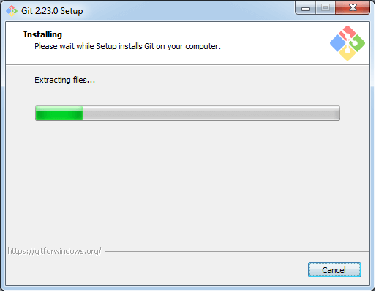

Therefore, The Git installation is completed. Now you can access the **Git Gui** and **Git Bash**.

The **Git Gui** looks like as

It facilitates with three features.

Create New Repository

Clone Existing Repository

Open Existing Repository

The **Git Bash** looks like as

